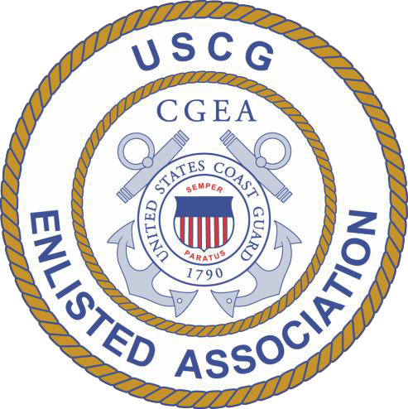

Prospected Nominee:
United States Coast Guard Enlisted Association
National Nomination Submission

MST1 Thomas Albert

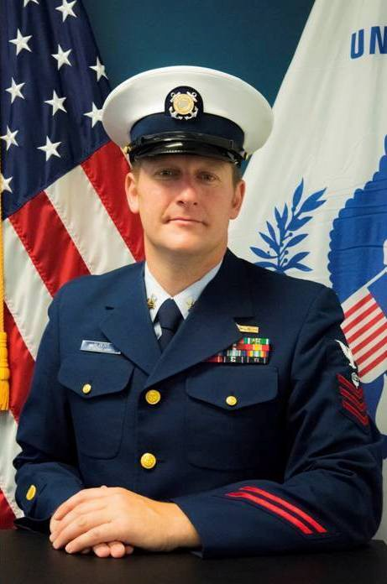
Position applying for:
Vice President

Enlisted Branch Name:
Los Angeles - Long Beach

Positions Held:
Glacier Branch (JUB) - Secretary
Diamond City Branch (DIB) - Secretary, Vice President Los Angeles - Long Beach Branch (LAB) - President

CGEA Accomplishments:

Primary point of contact when hosting CGEA-sponsored Run To Remember

events at my respective CG location from 2012-2015 and 2017, raising over $1,500 each time for the Coast Guard Foundation. Primary point of contact for Fitness Challenge in 2014, 2015, and 2017, creating friendly competition between units and members to begin or continue leading a healthy lifestyle.

38

Unit History:
MAY07-AUG08 NOV08-JUN12 JUL12-MAR16 APR16-SEP16
OCT16-Present
USCGC MIDGETT (Seattle, WA)
Sector Juneau (Juneau, AK)
Sector North Carolina (Wilmington, NC) Industry Training (San Pedro, CA)
Sector Los Angeles - Long Beach (San Pedro, CA)

Military Awards:
Coast Guard Commendation Medal Coast Guard Achievement Medal (2)
Commandant's Letter of Commendation Ribbon Good Conduct Award (3)
Military Outstanding Volunteer Service Medal (2)

Convention History:
Due to budgetary constraints, none attended

Goals for National CGEA:
I would like to see the continued success of the CGEA, including member growth

throughout our service. Membership, and more-so participation, have been noted issues with the CGEA since my joining in 2009. I would like to work with CGEA National and Branch officers to find a way to improve this.

Why do you feel you are a good candidate for the applied position?
I have been an avid supporter of the

CGEA, CPOA, CWOA, and their associated events for over eight years. I am interested in seeing the continued success of these organizations through the VP position at CGEA National. I am committed to being available for the assistance of CGEA Branches and others in the service.

CPOA endorsement (if available):
Petty Officer Albert has been a huge supporter of the CPOA and CGEA

since arriving to Sector LA/LB in October 2016. He routinely volunteers his off duty time at events coordinated by the CPOA, CGEA, and morale committee, as well as community events hosted by the Special Olympics, among others. His work with the CGEA, specifically regarding his organizational skills with the Run To Remember event in May 2017, helped raise over $1,500 for the Coast Guard Foundation. Aside from his volunteer efforts, Petty Officer Albert is the Leading Petty Officer of the Facilities Section at Sector LA/LB. He manages five junior petty officers and is responsible for the safety and security of the Ports of Los Angeles and Long Beach.

Petty Officer Albert would be serve to be a valuable asset for any position with CGEA National and is highly endorsed by the CPOA LA/LB Chapter.

CPO Michael Mueller LA/LB Chapter

ALBERT.THOMAS.

Digitally signed by ALBERT.THOMAS.ALAN.1296219467
DN: c=US, o=U.S. Government, ou=DoD,
ou=PKI, ou=USCG,

Thomas Albert, MST1
ALAN.1296219467 cn=ALBERT.THOMAS.ALAN.1296219467
Date: 2017.11.22 12:16:49 -08'00'

Applicants Printed Name Signature of Applicant
39

