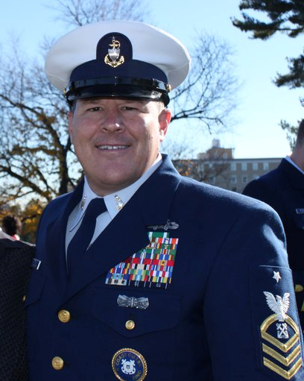
Nomination of
BMCS Jon Ostrowski
For
National President
USCG Chief Petty Officer Association

GREETINGS CHIEFS – I humbly submit my name and seek your vote to serve as National President of the USCG CPOA. I believe my vast experience in the USCG and my leadership in the CPOA and other non-profit organizations supporting and advocating for enlisted members of the armed forces will provide our CPOA with the experience, collaboration, and mentorship needed to grow and invigorate our membership.

PROVEN LEADER
I have been a member of the CPOA since 2006, served as Treasurer of the LA/LB Chapter, President and Vice President of the Washington D.C. Chapter, Co-Chairman of our National Membership Committee, and am a proud Silver Lifetime Member. During my service as a Chapter President, we were twice awarded the CPOA President’s Outstanding Chapter Award, raised over 120,000 dollars to restore the Coast Guard WWI memorial at Arlington National Cemetery, doubled our sponsorships, increased our membership by 10%. We worked diligently mentoring our junior enlisted culminating in the creation of a CGEA branch in Washington D.C. I also developed cooperative and collaborated with other organizations to enhance the CPOA’s reputation and engagement in the broader community. I also bring four years of experience as Director of Government Affairs at the Non Commissioned Officers Association in Washington; DC. This experience will serve the CPOA well on Capitol Hill, the Department of Veterans Affairs and our own Coast Guard Headquarters.

All of my activities will continue to focus on enhancing the CPOA’s reputation, providing our members tangible value for their membership, and foster an environment that adds value to our personal and professional lives.

My presidency would focus on the following areas:

- Build upon our recent partnership with the CG Foundation (helping CG families in need affected by this year’s hurricane season)…increasing awareness of who we are and what we do.
- Increase dialogue with Coast Guard Headquarters
- Attend and speak at functions in the DC Metro area in support of the CPOA.
- Work to lower BOD travel costs utilizing video teleconferencing and other communications technology available on the web.
- Purchase legislative software to give our membership a voice allowing our member's direct access to Congress regarding legislation important to them.
- Finally, work to increase membership to ensure our dues remain the same ($24) for many years. We have all lived by the saying throughout our Coast Guard careers; “Do more with less.” Well in my case “I will Do more with the same.”

In closing, if elected to serve as president of the CPOA, I would be humbled and honored to represent and serve the membership of this outstanding association. My agenda is your agenda. The hallmark of my leadership will be to incorporate and develop a consensus of our vision as an association by listening to your important ideas and thoughts to represent the entire CPOA membership. Thank you for you for taking the time to read my commitments to you.

https://www.linkedin.com/in/jrostrowski/

