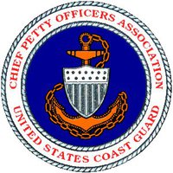
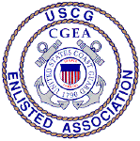
United States Coast Guard
CHIEF PETTY OFFICERS ASSOCIATION
5520 Hempstead Way
Springfield, VA 22151-4009
Phone: (703) 941-0395 / Fax: (703) 941-0397
Email: kimlorigan7@gmail.com (CPOA National President)
coastguardcpoa@gmail.com (National Office)

1 February 2018

CALL TO CONVENTION

Subj: 2018 CPOA / CGEA National Convention

1. As required by our Association’s By Laws, this letter serves as official notification that our Association’s Annual National Convention will be held from 20-23 August 2018 at the Sirata Beach Resort, 5300 Gulf Boulevard, St. Petersburg, Florida 33706.

2. All members in good standing have the right to speak on the Convention floor and vote on issues brought before the Assembly. The USCG CPOA Operations Manual states that a quorum at an Annual Convention consists of a majority of those members in good standing in attendance.

3. Motions to Amend the CPOA Operations Manual must be received at the National Office by not later than 22 April 2018. As this date falls on a weekend, Motions to Amend may be transmitted via fax to (703) 941-0397 or e-mailed to coastguardcpoa@gmail.com, and the submitter shall ensure that the original signed Motion is received at the National Office by not later than 23 April 2018. Motions to Amend received after that date will not be considered at the 2018 Convention.

4. Members wishing to dedicate this Convention to an individual, group, etc., shall petition the National President for approval at kimlorigan7@gmail.com. Once approved, the National Office will be directed to notify everyone concerned and prepare presentation certificates.

5. The tentative schedule for this year’s Convention will be made available by 15 May 2018 on the CPOA website at www.uscgcpoa.org, and will be published in the July 2018 edition of “The Chief”.

6. Robert's Rules of Order Newly Revised, 11th Edition,
by Henry M. III Robert, Daniel H. Honemann, Thomas J. Balch, Daniel E. Seabold & Shmuel Gerber, published by Da Capo Press, shall be the Parliamentary authority.

7. This notification will appear in the April 2018 edition of the “The Chief”. Motions to Amend the CPOA Operations Manual and the proposed 2018 Association Budget will appear in the July 2018 edition of “The Chief”.

Yours in Service,

YNC Kim Lorigan (Ret.)
CPOA National President

