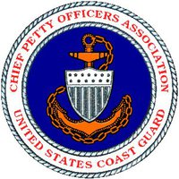
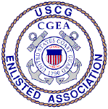
United States Coast Guard
CHIEF PETTY OFFICERS ASSOCIATION
5520 Hempstead Way
Springfield, VA 22151-4009
Phone: (703) 941-0395 / Fax: (703) 941-0397
Email: President@uscgcpoa.org (CPOA National President)
ExecutiveDirector@uscgcpoa.org (National Office)

29 January 2019

CALL TO CONVENTION

Subj: 2019 CPOA / CGEA National Convention

1. As required by our Association’s By Laws, this letter serves as official notification that our Association’s Annual National Convention will be held from 03-05 April 2019 at the Hyatt Regency Dulles Hotel, 2300 Dulles Corner Blvd, Herndon, Virginia 20171.

2. All members in good standing have the right to speak on the Convention floor and vote on issues brought before the Assembly. The USCG CPOA Operations Manual states that a quorum at an Annual Convention consists of a majority of those members in good standing in attendance.

3. Members wishing to dedicate this Convention to an individual, group, etc., shall petition the National President for approval at President@uscgcpoa.org. Once approved, the National Office will be directed to notify everyone concerned and prepare presentation certificates.

4. The tentative schedule for this year’s Convention are available on the CPOA website at www.uscgcpoa.org, and will be published in the April edition of “The Chief”.

5. Robert's Rules of Order Newly Revised, 11th Edition,
by Henry M. III Robert, Daniel H. Honemann, Thomas J. Balch, Daniel E. Seabold & Shmuel Gerber, published by Da Capo Press, shall be the Parliamentary authority.

6. This notification will appear in the April 2019 edition of the “The Chief”. The proposed 2020 Association Budget was published in the January 2019 edition of “The Chief”.

Yours in Service,

BMCS Jon Ostrowski (Ret.)
CPOA National President

